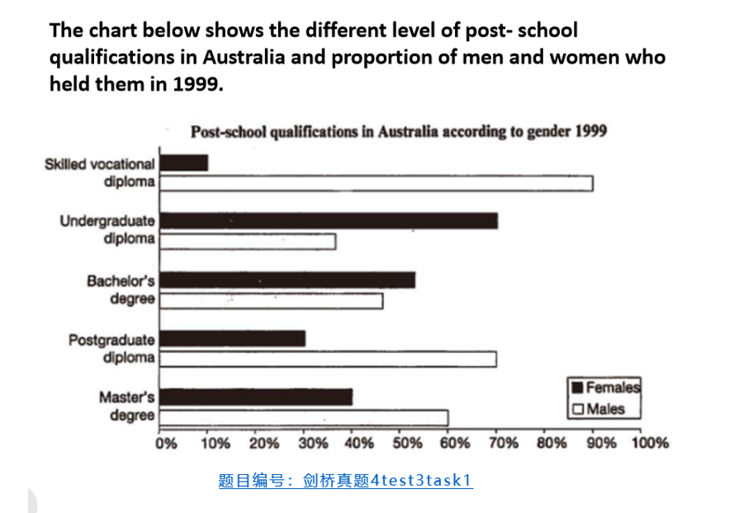

The bar graph illustrates the proportion of men and women holding different post-school qualification in Australia in 1999。
Overall, it was clear that there were quite difference in proportion of post-school qualification between two genders. Females tended to have a higher proportion in some qualifications like undergraduate diploma, while males dominated in others such as skilled vocational diploma.
Firstly, focusing on the most visible difference-skilled vocational diploma, which showed the male holders accounted for the vast majority among all qualification, reaching around 90%, while females’ proportion is only about 10%. By contrast, undergraduate diploma gave an opposite trend,females have a much higher proportion, approximately 70%, which is significantly higher than males’ proportion of about 40%. 过去式
For other qualifications, such as bachelor’s degree, the proportions of males and females are relatively closer but still show differences. In terms of Postgraduate diploma and Master's degree, although male both of these levels showed male majority, these proportions isn’t as much as that of skilled vocational diploma, approximately over 20% 过去式

